www.mermaidpoolsinc.com 182 W. 300 N. 3505 Fox Ridge Ln.
Anderson, IN 46012 Muncie, IN 47304 765-649-2229 765-284-7811
Pool Closing Form
Closing Date:
Name:
Address: City, State:
***Attention***
Pools will NOT be closed unless pre-paid or Credit Card on file to be charged after pool is closed.
Pool Closing Includes:
* Blowing suction and return lines with air and installing all winterizing equipment.
* Winterizing pump and filter.
* Hand rails and diving boards are NOT removed unless requested or necessary to install/close winter cover.
* Inspecting pool equipment: pump, filter, visible plumbing, booster pump and heater. We will give a written estimate of needed repairs.
* Installing all winter plugs and removing gauges.
* Winterizing of heater.

IMPORTANT THINGS TO REMEMBER:
- Technicians will not be able to balance water chemistry, we recommend bringing a pre-closing sample in store at least 48 hours prior to pool closing.
- Technicians will not provide any pool cleaning during closing.
- Leave all winterizing equipment and accessories easily visible from pool and within 10 feet of pool edge.
- Water and debris (leaves, sticks, etc.) must be removed from cover to avoid a $100.00 extra service fee that will automatically be added to closing if not performed by homeowner.
- Please insure that electricity is turned on to pool equipment.
- Additional service/repairs at closing (i.e., replacing seals, o-rings) will be charged for additional parts and labor.
Closing Labor (Check 1) | Price*
No Cover/Auto Cover Closing Labor | $150.00 | [ ]
Anchor/Waterbag Cover Closing Labor (Water tubes and cover straps not included) | $200.00 | [ ]
Chemicals (Check 1) | Price*
Closing chemicals (1 shock and 1 algaecide) | $54.46 | [ ]
Upgraded chemicals (2 shocks and 1 algaecide) | $73.67 | [ ]
Deluxe Chemicals (3 shocks and 2 algaecides) *15% off* | $108.91 | [ ]
**Technicians will only add Bioguard chemicals to pool. Please note in additional instructions if no chemicals are requested.
**Antifreeze (Check 1) | Price*
1 Pool Skimmer Package (6 gallons) | $44.94 | [ ]
2 Pool Skimmer Package (8 gallons) | $59.92 | [ ]
Water Feature/In Floor Clean System/Skimmer package (12 gallons) | $89.88 | [ ]
Above Ground Pools: No Main Drain (No antifreeze needed) | $0.00 | [ ]
Main Drain (2 gallons) | $12.84 | [ ]
**Additional antifreeze needed @ $7.49 per gallon will be added to or billed separately to closing.
Premium Options | Price*
Enzyme Cleaner *See attached Enzyme bulletin on how to help keep your pool clear. | $42.70 | [ ]
Salt System Cell Cleaning (Includes cell cleaner) | $50.00 | [ ]
Pump Protector- (Protects pumps/valves during winter shutdown. After shutting off water | $20.00 | [ ]
seals/gaskets can dry out. This process will help protect them from corrosion and locking up.)
*Price includes tax.
Additional Instructions: ________________________________________________________________________
_____________________________________________________________________________________________

Payment is due either prior to service or charged to a credit card on file following the completion of service.
[ ] Prepay- with check enclosed or cash/check at store before closing. I understand that if there are additional charges at the time of the closing, I will pay for those charges by check or credit card within 7 days of service.
[ ] Credit Card on file (If card is on file with us, make sure expiration date and credit card information is current)

Customer Signature: _____________________________________ Date: ____________
Form must be received 3 days prior to service. You may drop off or mail form to either store location.
You may email form to Mark@mermaidpoolsinc.com or fax to 765-649-2686.

Payment Information [ ] Visa [ ] Mastercard [ ] Discover
Card Number: ____________________________________________ Exp. Date: __________
CVV#:_____ *Please include 3 or 4 digit number on back of card. [ ] Please keep my credit card on file for future payments.
Page 1 of 2
Winter Closing Materials Order Form
Save 10% on closing materials when ordering with your pool closing.

Qty | Product | Reg. Price (tax included) | Discount Price (tax included)
[ ] | Water Tube 10’ Double Chamber | $10.65 | $9.58
[ ] | Water Tube 10’ Double Chamber Deluxe | $12.79 | $11.51
[ ] | Air Pillow 4’x4’ | $9.58 | $8.62
[ ] | Air Pillow 4’x8’ | $18.14 | $16.32
[ ] | Winter Plug w/ o-ring | $4.23 | $3.80
[ ] | O-ring for winter plug | $1.61 | $1.44
[ ] | Skimmer blowout Gizmo | $13.86 | $12.47
[ ] | Stow-Away (Cleaner/deodorizer for solar/auto cover.) | $17.07 | $15.36

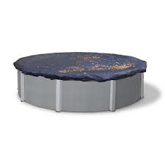
Winter Covers
Save 25% on all waterbag/tie down covers when ordered with your closing. Three styles to choose from: Standard, Deluxe and Supreme. Speak to any sales associate to order yours today. (Not all cover sizes in stock and may take 2-3 days to receive. Cover charge will be added to closing charge or prepaid.)

In-ground safety covers can be special ordered to fit pool size. Call or email ebaker@mermaidpoolsinc.com for your free quote to start the process. Safety covers take approximately 2-3 weeks to receive.

Need a new liner, heater or energy efficient pump?
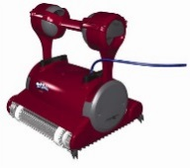
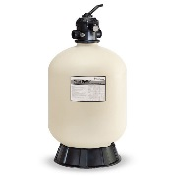
With our new Easy Pay Program you can pay for the pool equipment or patio accessories you’ll need next year throughout the winter.
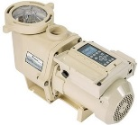

For your convenience we can schedule easy monthly payments with a 15% deposit.
Plan ahead for next summer now!
Ask any store associate for program details.

New MiniMax Egg
The newest Big Green Egg is the MiniMax. Perfect for Egg lovers on the go. This smoker comes with a sturdy easy grip carrier. A MiniMax can cook a 12 lb turkey, 1 chicken or 4 burgers… great poolside!
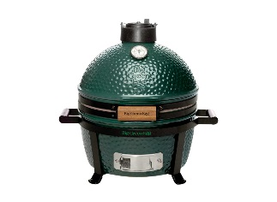
$598
Get your MiniMax
today just in time for tailgating season!
*Price doesn’t include tax.
Clearance Furniture Set!
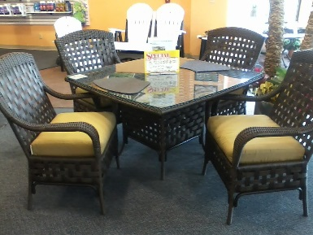
Lloyd Flanders

-Wicker table w/ glass
Top
-4 Chairs w/ cushions

Now $1500
Savings of $3188
*Sale price doesn’t include tax. While set is in-stock.

Don’t miss out on savings!

Remember February is the best time to stock up on all your BioGuard Chemicals.
The whole month of February save 20% on qualified season supplies of pool and spa chemicals!
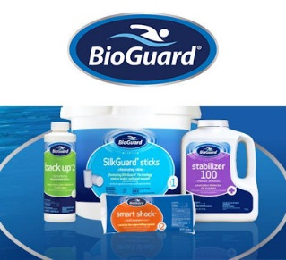

Email us at
info@mermaidpoolsinc.com
to sign up for our newsletter.

